The Complete Guide to Finishing a Basement

* Published on June 1, 2022
* Revised on February 15, 2023
* 28 min read

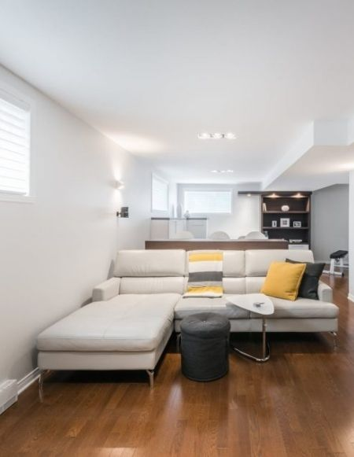

Finishing a basement isn’t always easy. Your makeshift junk room must be emptied, renovation costs can increase rapidly, and your once beloved neon orange shag carpet may not be the statement piece you want down there anymore. Whether you’re about to embark on a basement renovation for the first time or looking to give a finished one a makeover, this is your chance to leverage that extra square footage to transform your home. Here are the steps to finishing a basement.

How to prepare for a basement renovation

Like any major renovation project, finishing a basement requires some [preparation](https://www.renoassistance.ca/en/advice/tips-for-a-major-renovation/). Before you start buying flooring and putting up drywall, think about your current and long-term needs. For example, basement bedrooms for the kids may seem like a great idea, but what’ll happen to that space after they’ve left the nest? You’re investing a fair bit of money into your basement renovation, so you want it to age well.

You should also think about living arrangements. If you live in a smaller house, like a bungalow, or have sensory issues, you may want to consider living elsewhere during the renovation. It could be a great opportunity to stay with friends or family or go on that road trip to the Maritimes you’ve been putting off for a while. Similarly, if you’ve been using your basement as a storage unit, you may want to consider storage solutions. You can also take the opportunity to do a major clean-up and donate or sell things you no longer use or that won’t fit into your new design. The more you get rid of, the easier it’ll be to store things you want to keep.

Basement renovation options

Finishing a basement gives you a lot of space to work with: you can transform it into anything you want! Here are a few ideas to get you started.

* **Bedroom.**Whether it’s for the kids or guests, or a secondary suite, a bedroom can provide some much-needed privacy away from other home activities. Just make sure that your basement has windows large enough to serve as an emergency exit (see *Doors and Windows*).
* **Home office.** Working from home has become the norm, so take the opportunity to create a dedicated work space away from distractions. Be sure to add some elements for relaxation, like plants, an electric fireplace, and a snack station.
* **Home studio.**Those who love to create or work with their hands may want a dedicated space to hone their craft(s). Whether you’re painting miniatures or upcycling old electronics, add any special features you need, such as integrated shelving, a drying rack, or ventilation.
* **Recreation room.** Take advantage of the space by creating a large open area. Create a kids’ playroom – or one for adults – featuring videogames, a pool table, or a ping pong table.
* **Home theatre.**If your family loves to relax and watch shows on the sofa, then a home theatre is a must. The basement is the darkest part of the home, so it’s great for replicating the hushed atmosphere found in a cinema. Just add in some cozy chairs and a snack bar and you’re set!
* **Home gym.** People who like to move but don’t always have the time to go to the gym can create one at home. In addition to the traditional equipment, a wall-mounted television connected to the internet will let you follow any kind of class offered online, like yoga, kickboxing, or bodybuilding.
* **Library.** If all you want is some quality time with a good book, then feel free to bring your dream library to life. Line the walls with floor-to-ceiling bookcases, hang those wrought iron candleholders, show off those vintage velour chaises… and lose yourself in your next story.

No matter the route you take, remember to include some storage space for seasonal items like camping equipment and holiday decorations. Also, if you have some room in your budget, consider adding a bathroom. It’ll increase the value of your home and add convenience – you don’t have to go upstairs to use the toilet! And, if it’s big enough, you can even add a washer and dryer.

Decorating

Now that your basement renovation has a direction, it’s time to think about your desired aesthetic. Browse the [latest trends](https://www.renoassistance.ca/en/basement/basement-trends/) and completed basement projects to get a feel for what you like. Keep in mind that your style preferences will influence your material purchases.

If you don’t want to redecorate in a few years, consider incorporating a few versatile or timeless elements like light-coloured wood, neutral flooring, and recessed lighting. They’re also easy to work with, so you can swap in bigger and bolder pieces like elaborate light fixtures without them making the room too loud.

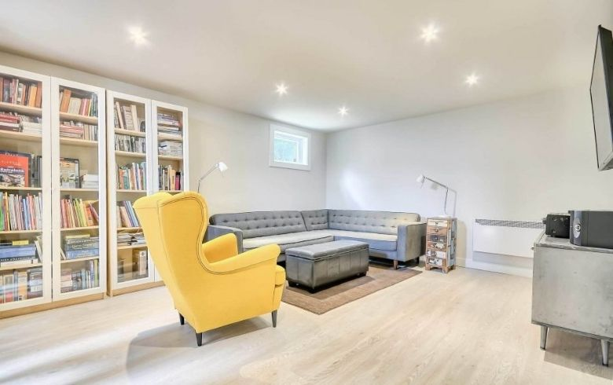

Basement rental

If your home already provides you with all the space you need, consider building a [basement rental apartment](https://www.renoassistance.ca/en/basement/converting-your-basement-into-a-rental/) or secondary suite. If you want to go this route, you’ll first need to ensure that your municipality allows this type of conversion. Then, your basement will need to meet [Code requirements](https://www.renoassistance.ca/en/advice/legal-basement-apartment/) (e.g., minimum ceiling heights, emergency exits, fire-separation requirements).

While there are many steps in finishing a basement rental (building a kitchen, a full bathroom, and a separate entrance), it’ll bring in extra income that could help you pay your mortgage or enjoy a more comfortable retirement. Of course, this income will be taxable. However, several expenses are [tax deductible](https://www.renoassistance.ca/en/advice/basement-rental-tax-deductions/), such as maintaining or improving the unit.

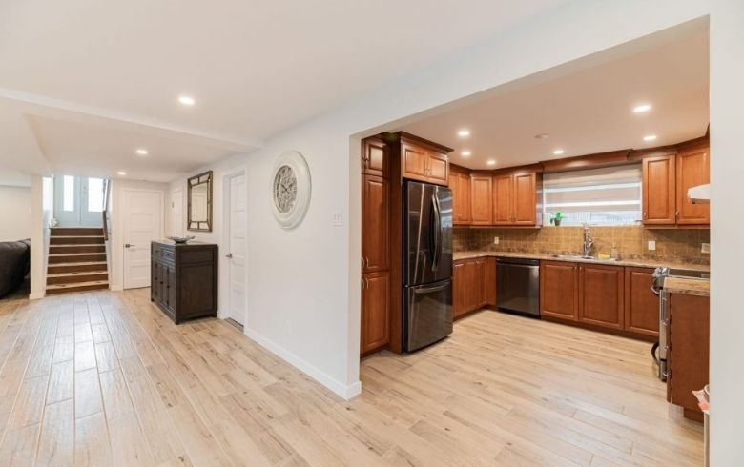

Inspection

One crucial step remains before starting a basement renovation project: getting your basement inspected to uncover problems. Without a doubt, [basement humidity](https://www.renoassistance.ca/en/decontamination-mold/basement-humidity/) is the most common concern, and it’s often caused by water infiltration. Here are a few other things to look out for:

* Insufficient insulation
* Cracked concrete slab
* Cracks in the foundation (if you have drywall, look for small puddles on the floor during heavy rain)
* Mould
* Poor ventilation
* Presence of pyrite, [iron ochre](https://www.renoassistance.ca/en/decontamination-mold/iron-ochre/), or radon

It’s best to fix these problems before finishing a basement; you really don’t want your new floors to start buckling or have mould growing on your brand-new wall panelling. Don’t forget to set aside some money for possible repairs and decontamination work.

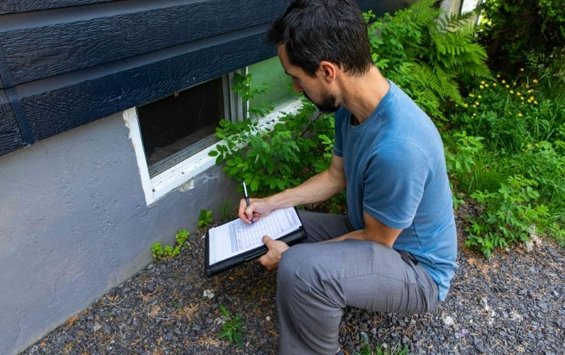

Planning your budget

Like with any major project, you need to decide how much you’re willing to spend and establish a budget range. It’s easy to get distracted by built-in and custom products or the latest hardwood flooring, so keep track of your expenses. If it helps, pick one place to splurge so that you have something to look forward to!

Here are the [costs for finishing a basement](https://www.renoassistance.ca/en/basement/basement-renovation-cost/) (supplies and labour). That said, be sure to set aside about 15% to 20% of your budget for emergencies and unexpected cost overruns.

|  |  |
| --- | --- |
| Turnkey basement (without bathroom) | $25,000 to $63,000 |
| Bathroom | $10,000 to $28,000 |
| Walls and joint sealing | $2 to $3/sq. ft. for drywall; $1,500 to $1,900 for joint sealing |
| Ceiling | $3.00 to $6.25/sq. ft. |
| Insulation | $2.00 to $3.75/sq. ft. |
| Floor | $3.00 to $14/sq. ft. |

If your budget is a bit tight, there are a few ways to [save money during your basement renovation](https://www.renoassistance.ca/en/basement/basement-cost-saving-tips/). For example, you can choose not to close off the ceiling and instead use the beams to decorate (like with string lights) or paint the existing concrete instead of covering it with drywall.

When is the best time to renovate your basement?

Since most of the work will be done indoors, a basement renovation can be done any time of year. That said, there are several advantages to [renovating in winter](https://www.renoassistance.ca/en/advice/renovating-in-the-winter/). For example, contractors and subcontractors typically have better availability, and permit wait times are generally shorter. Material and labour costs also tend to be lower, giving you a chance to [save money on your renovation](https://www.renoassistance.ca/en/hiring-contractors/save-money-on-your-home-renovation/).

Steps to finishing a basement: Drafting the floor plans

Whether you’re building a secondary suite or the perfect artist studio, you’re going to need someone to draft your floor plans. This can be done by a general contractor, an [interior designer](https://www.renoassistance.ca/en/home-renovations/interior-design/), or an [architect](https://www.renoassistance.ca/en/home-renovations/architects-technologists/) or [architectural technologist](https://www.renoassistance.ca/en/home-renovations/technologists/).

While both [architects and technologists](https://www.renoassistance.ca/en/advice/architect-vs-architectural-technologist/) are capable of drafting your basement renovation plans, there are a few key differences in scope and price point. For example, only an architect can work on single-family homes that are larger than 600 sq. m. (≈ 6,458 sq. ft.), and they typically give you a cost estimate and manage the construction site for your project. They also charge more than technologists (8–10% vs. 1–3%).

If you’re not sure who to hire, feel free to reach out to one of our Renovation Advisors!

Steps to finishing a basement: Electrical, plumbing, and HVAC

Once you’ve got your basement floor plans, you’ll need to figure out your electrical and plumbing needs. HVAC should also be considered to maintain a comfortable temperature.

Electrical components

When finishing a basement, take the time to add or repair electrical outlets, especially if you’re building new rooms. And, unless you want a dark and gloomy space, you’ll want to complement the natural light from the windows with light fixtures. Add a two-way switch for the stairway light, as well!

If you think you’ll be using a lot of power downstairs, you may want to upgrade your electrical panel. You can also camouflage your panel if it’ll end up being inside of a bedroom closet, for example. Note that you’ll need a licensed electrician for all electrical work.

Plumbing

Like with electricity, you’ll need a licensed plumber if you’re planning to move or install a water heater, a washing machine, or any other bathroom fixture (e.g., toilet, sink).

Bathroom

It’s common to add a bathroom to the basement – it’s convenient, after all! Before you get too far into the design phase, think about who will be using the bathroom and how often. Storage solutions might also be needed, especially if it’s part of a secondary suite or if you plan to build bedrooms in the space. There are lots of ways you can [optimize a small space](https://www.renoassistance.ca/en/bathrooms/maximize-your-small-bathroom-space/), too, if you’re working with a tight floor plan. And if you’re upgrading a pre-existing basement bathroom, you could also [replace the bathtub](https://www.renoassistance.ca/en/bathrooms/shower-conversion/) with the shower of your dreams.

If possible, try to position your basement bathroom directly below the one on the ground floor. It’ll make installing and connecting pipes a lot easier, and it’ll help lower costs. Draining waste water might be an issue though. If your drain’s slope, depth, and piping aren’t up to Code, you may need to break into the concrete slab to fix it.

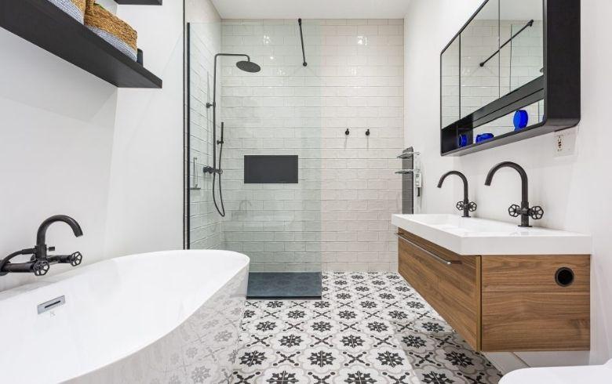

Laundry room

Even if it’s not finished, your basement has the hookups for a washer and dryer. If you want to move their location to your future bathroom, you’ll need a drain to deal with potential overflows. You’ll also need access to an exterior wall to install the vent for the dryer.

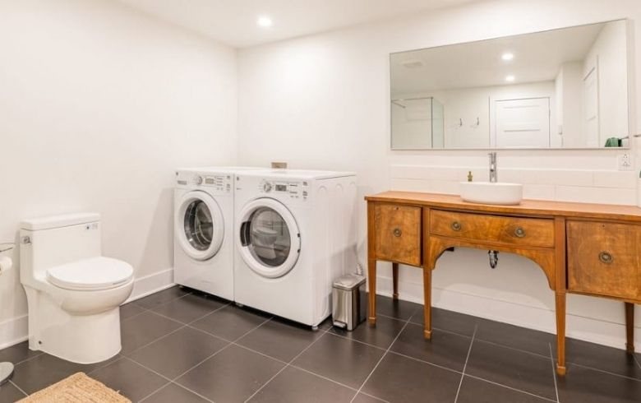

HVAC system

Between the frigid winter cold and the hot and humid summers, you’ll need an HVAC system to keep your basement’s temperature and [humidity](https://www.renoassistance.ca/en/decontamination-mold/basement-humidity/) level comfortable. Poor ventilation can not only cause your drywall to deteriorate but also breed mould. And, if you install a bathroom with a shower, you’ll need an exhaust fan.

If your house isn’t new, you can take this opportunity to swap your oil-burning furnace for an electric heat pump. It’ll reduce your hydro bill while keeping you cool during the summer and warm during the winter. There are a few other [HVAC solutions](https://www.renoassistance.ca/en/heating-and-air-conditioning/hvac-system-cost/) available, so be sure to shop around.

Steps to finishing a basement: Walls, doors, windows, and stairs

The next step in your basement renovation involves the flat surfaces and entry: the walls, floors, ceiling, and access stairs. After the safety factors are accounted for, you can dress them up in your desired aesthetic!

Basement walls

If you’re not fond of the look of unfinished basement walls, you’re in the right place! There are lots of ways to turn that boring concrete into something beautiful, so feel free to play around with textures and colours. Before you get too caught up in your basement renovation, make sure your foundation walls are good to go.

Insulating foundation walls

Before finishing a basement, be sure to inspect your foundation walls. It’d be a real shame if you put up your insulation and drywall without realizing that they had cracks or signs of [water infiltration](https://www.renoassistance.ca/en/disaster/water-infiltration/) or [efflorescence](https://en.wikipedia.org/wiki/Efflorescence). If you find an issue, be sure to get it repaired. In the meantime, here are some ways you can [waterproof your basement](https://www.renoassistance.ca/en/basement/basement-waterproofing/):

* Get a dehumidifier
* Repair foundation cracks
* Apply waterproof paint
* Install a sump pump
* Ensure the ground around your house is gently sloped to divert runoff
* Inspect basement window wells
* Clean out your gutters
* Install or repair your [French drain](https://www.renoassistance.ca/en/french-drains/french-drain-problems/)

If your basement renovation requires excavation, take the opportunity to [insulate](https://www.renoassistance.ca/en/home-general-renovations/house-insulation/) your home’s exterior using extruded polystyrene or rigid fibreglass. It’ll help protect the walls against dampness and freezing, and you’ll also [save energy](https://www.nrcan.gc.ca/energy-efficiency/homes/make-your-home-more-energy-efficient/keeping-the-heat/section-6-basement-insulation-floors-walls-and-crawl-spaces/15639).

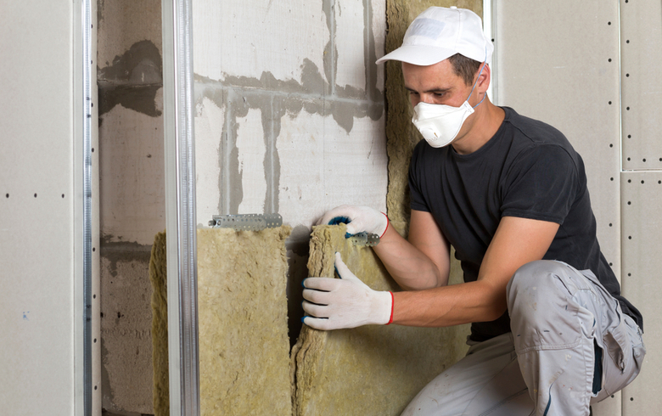

Building walls

Humidity-resistant drywall is typically the go-to for basements, especially in the bathroom, laundry room, and utility room. You can also use gypsum board, which is inexpensive and easy to replace if leaks ever occur.

After you’ve put up the base of your wall, it’s time to decorate! You can paint your drywall with any colour or finish you like. You can also add texture using [tadelakt](https://en.wikipedia.org/wiki/Tadelakt" \t "_blank), roughcast, stucco, or wax concrete sealer for a unique ambience. If you’re big on patterns, you’re in luck – wallpaper has made a comeback.

If you’re looking for a more modern or contemporary touch, feel free to play with wood accents. You can use dark wood sparingly to highlight certain details or use pale wood liberally to mimic shiplap. Brick and stone (real or fake) can be great for accent walls or wine cellars, and you can even paint them or leave them as is. If you really want to spice things up, browse decorative panels. They’re a bit more expensive, but they’re gorgeous and fantastic at hiding imperfections.

Basement doors and windows

It’s easy to forget about windows and doors during a basement renovation project, but you’ll need them to bring your space up to Code and to separate areas. For example, bathrooms, guest rooms, and offices all need doors for privacy. You may also want to install a door at the top of the stairs leading to the main floor to reduce noise. And, of course, if you’re building a secondary suite, you’ll need a separate entrance.

No matter how you plan to use the space, the Building Code requires at least one emergency exit. If you don’t have a door that leads outside, then you’ll need a few windows big enough to serve as an exit.

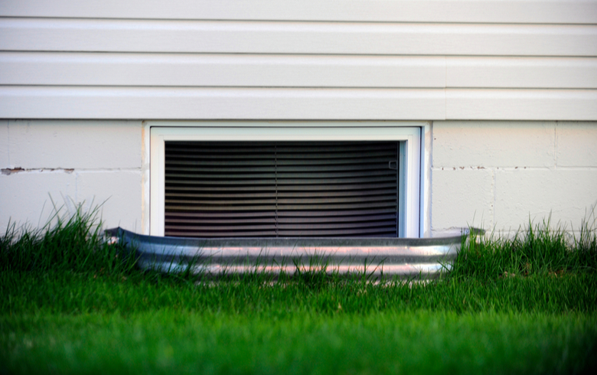

Add or change windows

Most of the time, newly constructed homes come with an unfinished basement and very small windows. The standards for minimum window dimensions only apply if the basement contains a bedroom (see *Window standards*).

Even if your basement renovation won’t include building bedrooms, you may still want to change the windows or to add some to bring in more natural light. Either way, this is a major project because new openings will have to be made in the foundation. Alternatively, you could just replace the old windows to improve their energy efficiency.

In theory, all [kinds of windows](https://www.renoassistance.ca/en/windows-and-doors/window-types/) can be installed in a basement. However, practical considerations may limit your choice. For example, a snowstorm or obstacle could prevent you from opening a casement or awning window. That’s why a sliding window is the most common type in basements. To prevent the window from being exposed to too much humidity, be sure it is installed at least 8 to 10 inches from the ground. If this isn’t possible, you will have to install a window well.

Door and window prices

[Window prices](https://www.renoassistance.ca/en/windows-and-doors/pvc-window-replacement-cost/) vary by model, material (PVC, aluminum, wood), number of panes (double- or triple-glazed), size, and quality. PVC window replacement costs about $1,200 per window.

This is an average, so changing a basement window may turn out to be less expensive, especially for sliding windows. This model is among the least expensive because it doesn’t require hardware (e.g., a handle to crank it open). In addition, basement windows are usually smaller than those in the rest of a house, which will reduce the cost.

Window standards

If you decide to build one or more bedrooms in the basement, they must include windows that can serve as an emergency exit (egress), unless a sprinkler system is installed. The rules in [Ontario](https://www.ontario.ca/page/add-second-unit-your-house) and [Quebec](https://www.acq.org/wp-content/uploads/2020/03/residentiel-fiches-techniques-fenetres-portes-evacuation.pdf) are slightly different.

**Ontario**

* Unobstructed opening at least 0.38 sq. m. (4.1 sq. ft.)
* Openable portion of window at least 0.46 m (18 in)
* Base of window no more than 0.9 m (2’11”) above floor or steps
* At least 1 m (3’3”) of clearance either past the edge of the fully open window (for an out-swinging window) or the wall (for an in-swinging window)

**Quebec**

* Unobstructed opening at least 0.35 sq. m. (3.8 sq. ft.)
* All window dimensions must be at least 0.38 m (15 in)
* At least 0.76 m (30 in) of clearance in front of the window

Be sure to keep the area in front of your window well clear of debris and snow. Also, don’t install window screens or bars on your egress – if you can’t get in, you can’t get out either!

Basement stairs

The next step in finishing a basement is connecting it to the main floor with some stairs. From simple straight carpeted stairs to floating glass spiral staircases, your design choices are virtually endless. Let’s go over the three main types of staircases: straight, turning, and winding (spiral).

Straight staircases are the most common – they’re easy to design and build, and they’re inexpensive. While they take up a fair bit of space, you can use the room underneath them for storage or an office nook.

You can also go for a turning staircase (e.g., L-shaped, or U-shaped) with or without a landing. It costs a bit more than a straight staircase, but it takes up less space. And, if you really want that bit of luxury, you can invest in a spiral staircase. Just keep in mind that while they take up very little space, they are steeper and narrower. This makes them less safe for seniors, folks with mobility issues, and young children, as well as useless for moving bulky objects or furniture.

Once you’ve picked your staircase type, it’s time to move on to materials. Here are some of the classics!

* **Carpet.** This popular material is soft underfoot and provides a bit of soundproofing. It’s easy to install but does wear out quickly.
* **Hardwood.** A classic, this material comes in a variety of stains to match your decor. It’s strong and durable – it lasts a long time!
* **Ceramic.** Mix and match your favourite colours and patterns with ceramic tiles. They’re easy to clean, too! That said, they can be cold underfoot, especially in the winter.
* **Vinyl.**This budget-friendly option lets you get a luxe look at a fraction of the cost.

Remember that staircases must meet Building Code standards for railings, steps, and risers.

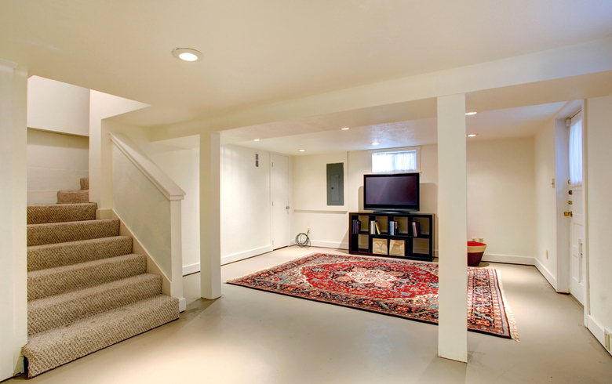

Basement floors

Before you order your future basement flooring material, you need to check a few things (humidity, concrete slab slope, ceiling height, etc.). In some cases, you might need a subfloor. That said, you may choose to have one built anyway just to make the floor warmer and to keep the heat in. Otherwise, you can install your flooring right on the concrete.

Raised floor

Raised floors are great if your concrete slab is damp or has a steep slope. To build one, your contractor will cover the slab with a vapour barrier. Then, they’ll install a wood frame and screw plywood into it. The underlayment membrane then goes on top, followed by your choice of flooring. Just remember that you still need 2.1 m (6.8 ft) of clearance between the finished floor and the ceiling.

Floating floor with a drainage membrane

If you have a low ceiling and the slab slope is minimal, a drainage membrane could also work. It’s made of a vapour barrier material and features studs that allow air and water to flow above the concrete slab. The membrane is then usually covered with a flexible underlay or by plywood and an underlay, followed by your flooring.

Basement flooring ideas

There are tons of flooring options to choose from for your basement renovation, but some are better than others. For example, hardwood isn’t great because it’s less resistant to humidity, and carpeting tends to retain humidity, creating a musty smell. If you really want something soft to walk on, opt for area rugs or carpet tiles. They’re easy to remove and clean after minor water leaks.

That said, here are some of the best basement flooring ideas; they’re all highly resistant to water and humidity!

* Engineered wood
* Laminate
* Linoleum
* Vinyl
* Ceramic
* Epoxy

Floor heating systems

If you’re going to be using your basement all year round, invest in your comfort. Floor heating systems are great in that they provide uniform heating, don’t need maintenance, are easy to install, and are energy efficient. They do raise the floor height slightly, so be careful if you have low ceilings. They also cost a bit more than your average floor.

There are two types of floor heating systems: electric and hot water. First, insulation sheets are installed on a level concrete slab. For an electric system, the sheets are covered with heating cables and attached with clips; for a hot water system, copper or synthetic tubes are installed. Last, the floor panels are installed, or concrete is poured over top.

Basement ceiling

While you don’t have to install a ceiling, your basement may look incomplete without one. Besides, a basement renovation gives you the opportunity to [install soundproofing](https://www.renoassistance.ca/en/basement/soundproofing-basement-ceiling/) and to use some interesting materials to complete your aesthetic. Here are a few ideas to get you started.

Suspended ceiling

Made up of a simple grid and lightweight square or rectangular panels, a suspended ceiling (or drop ceiling) is a popular choice for basements. While it provides easy access to plumbing and electrical lines, its visual appearance makes it almost impossible to forget that you’re in a basement. Fortunately, there are more aesthetic options such as ceiling tiles that imitate wood or copper.

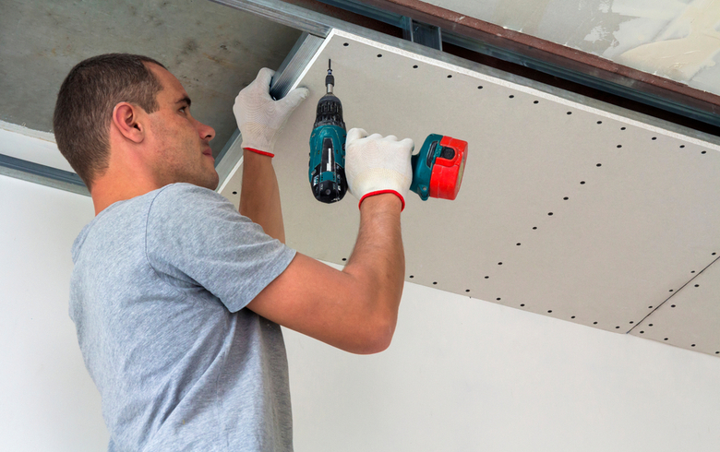

Gypsum ceiling

Gypsum ceilings are another great option: they add elegance and are easy to paint. If you have a small basement, you can use a lighter shade to make the room look larger. The installation process is a bit messy, especially the seam sanding stage because it creates a lot of dust, so make sure the contractor provides clean-up services if you go this route. Also, if you want better soundproofing, opt for acoustic gypsum instead of regular.

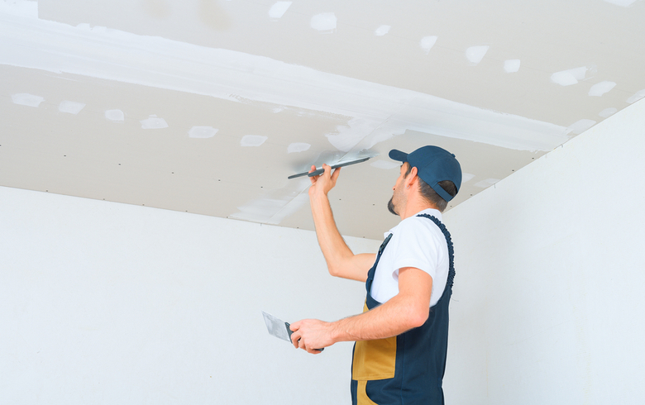

Wood ceiling

If you’re looking to add some warmth, wood ceilings are a great choice! They produce less dust than gypsum, are quick to install, and, unlike drywall, don’t need primer or several coats of paint. Wood panels are also light and easy to handle. They are a bit more expensive than gypsum, but they’re worth it if you like the aesthetic.

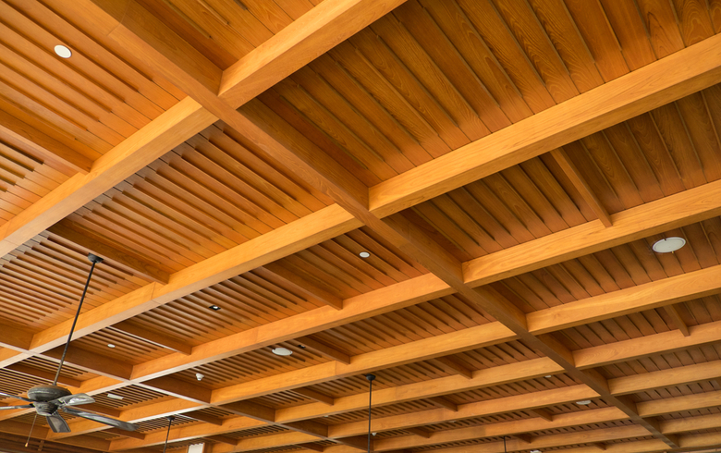

Steps to finishing a basement: Finding the right contractor

A basement renovation is a huge project – it requires a lot of planning and experience. Before you get started, take some time to pick a contractor you’re comfortable with and confident in.

What type of contractor should I use?

Whether you’re finishing a basement or constructing one from scratch, you’re going to need a team of qualified professionals to get the job done. The best plan of action is to hire a general contractor and have them find and manage the specialized tradespeople you need. They have contacts in the industry and people they prefer to work with on projects.

You could coordinate everything yourself, but that requires taking the time to vet each contractor. It’s a lot easier to let an experienced professional, like one of our [Verified Contractors](https://www.renoassistance.ca/en/360-verification/), handle those details for you. You’ll save time and money, resulting in a less stressful basement renovation experience.

Here are the types of renovation professionals you might be working with:

* woodworker
* plumber
* electrician
* painter
* carpenter
* HVAC technician
* excavation operator
* foundation contractor
* concrete finisher
* engineer

You can also hire an interior designer, architect, or architectural technologist to design your basement to fit your needs and aesthetic.

Questions to ask your contractor

One of the most important steps to finishing a basement is picking the right professionals for the job. To make sure your basement renovation goes off without a hitch, here’s a [list of questions](https://www.renoassistance.ca/en/hiring-contractors/questions-to-ask-a-contractor/) to ask potential contractors:

* **Do you have a licence?**In Quebec, a contractor must hold the appropriate RBQ licence ([1.2](https://www.rbq.gouv.qc.ca/en/online-services/licence/determining-the-required-licence/list-of-subclasses.html?tx_gdlr_pi1%5Bannexe%5D=9&tx_gdlr_pi1%5Bsubcat%5D=65) and/or [1.3](https://www.rbq.gouv.qc.ca/en/online-services/licence/determining-the-required-licence/list-of-subclasses.html?tx_gdlr_pi1%5Bannexe%5D=9&tx_gdlr_pi1%5Bsubcat%5D=65)). In Ontario, you can ask your contractor if they have a licence or a [Certificate of Qualification](https://www.skilledtradesontario.ca/apprenticeship/provisional-certificate-of-qualification/) for their compulsory or non-compulsory trade, respectively.
* **Do you have contractor liability insurance?** Make sure your contractor is insured to protect yourself and your home. Ask to see their insurance certificate and check to make sure it is valid.
* **How long have you been in business?** Ask the contractor how long they’ve been in business for and double check with [ServiceOntario](https://www.ontario.ca/page/serviceontario" \t "_blank) for Ontario-based contractors or le[Registraire des entreprises](http://www.registreentreprises.gouv.qc.ca/en/) for Quebec-based contractors.
* **Who are your main suppliers?** If the contractor has been using the same suppliers for a long time, it means they have a good business relationship and that the supplier is paid on time.
* **Do you always use products from the same manufacturer?** If the answer is yes, the contractor may like them because they provide high quality products. That said, they may also be old friends, which could create a conflict of interest or increase costs for you.
* **How long will the work take?** Establish a detailed schedule so you can monitor how work is progressing.
* **Is the price of the work likely to increase during the project?** Avoid unexpected surprises and ask the contractor which issues could lead to price increases.
* **Who will be my main contact on this project?** It’s best to deal with just one person; it’ll help prevent misunderstandings and communication issues.
* **What are the terms of payment?** Put together a detailed payment schedule with your contractor beforehand and ensure it’s included in your contract.

If you don’t have the time or energy to vet a bunch of contractors, you can always work with one of ours. We’ve already vetted them using the most thorough verification process in the industry, so you can rest assured knowing that you’ll only work with the best.

Signs that it’s time for a basement renovation

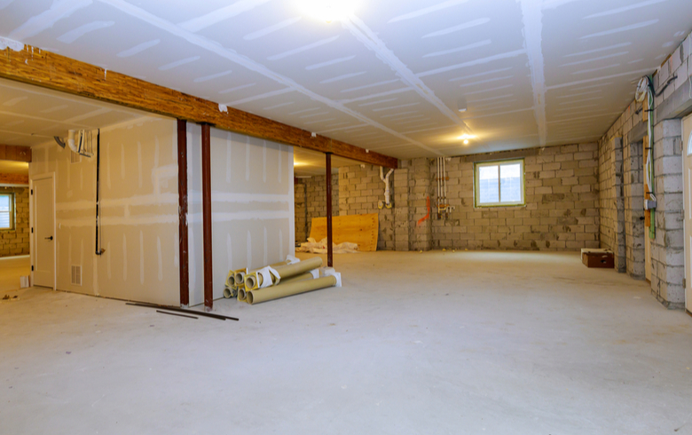

Maybe you’ve been thinking about finishing a basement for years but are still hesitating. Maybe you’ve been inspired by the latest home renovation shows on television, but you’re still afraid to dive into a new project. Or maybe you’ve noticed that your makeshift storage space looks a little worse for wear. Whatever the reason, here are a few signs that it’s time to take the plunge.

Your basement isn’t finished

There’s not much more depressing than going downstairs to a room filled with cold concrete walls and floors, exposed ventilation ducts and plumbing, and dampness. Transforming this austere area into a comfortable basement will not only add more square footage to enjoy but also increase your home’s value.

There is visible damage

Deformed walls, cracks in the concrete floor, insect infestations (e.g., [carpenter ants](https://www.renoassistance.ca/en/decontamination-mold/carpenter-ants/))… a lot can happen in an unused room over time. An experienced contractor can help address them and point out some of the less obvious issues that you may not have noticed.

You aren’t happy with your basement

Were you one of those people that jumped on the bandwagon and created a basement family room where you could watch movies and the kids could play with their toys? You’re not alone. Often basement renovations are completed without considering the lighting or atmosphere, resulting in dark, gloomy, and generally uninviting spaces. Now’s your chance to reclaim that square footage and create a space that’ll get some use! Add decorative elements and new finishes or even start from scratch to create a room (or rooms) that better fit your family’s needs.

Major water damage

Leaks and water damage are the types of issues you can’t really ignore. If you don’t remove damp items and dry out the space, you’ll end up with a mould problem. When this happens, a basement renovation is necessary to address real health concerns, but you can also take some time to update the aesthetic, too. Two birds, one stone.

Basement renovation process



The steps to finishing a basement will depend on the scope of your project: they can be straightforward, such as when building a single large room, or complex, such as when building a soundproof studio. No matter what your dream basement looks like, the major steps tend to be the same.

Planning

Basement renovations take a long time, so it’s important to plan ahead. Be sure to book a contractor and any other renovation professionals needed ahead of time and ensure they understand your vision. Also establish a detailed work schedule. This’ll help them get everything they need sorted, such as ordering materials in time for the project’s start date.

Inspection

Before construction begins, make sure you get your basement inspected. Not only will it help your contractor better understand any potential issues that need to be addressed, but it’ll also help you save money in the long run. After all, no one wants to redo a basement renovation in a few years because of an overlooked humidity problem.

Deconstruction (if needed)

If your basement is already finished but not to your liking, take some time to remove the finishing from the floors, walls, and ceiling, as well as from the bathroom. You can reuse or refinish these materials if you still like them or install entirely new elements.

Plumbing and electrical

Depending on what you’re planning, your plumbing or electrical may need some work. For example, a new bathroom would need new pipes, while a home theatre may need new electrical for a high-quality sound system.

Construction

The big day has finally arrived, and construction is about to start! If you notice something was left out or anything that could potentially delay the project, be sure to talk to your general contractor and let them know.

Finishing

Some contractors will stay until the finishing touches are complete while others will take off once the essentials are done. If you’re not good with your hands or don’t want to do this part yourself, be sure to talk to your contractor and outline about what a finished project looks like.

Clean-up

Before you sign your contract, make sure that debris disposal is included as part of your basement renovation. If not, have it added in a clause. With this type of project, there will be a lot of clean-ups and a lot of trash, especially if the contractors need to take apart a finished basement. You don’t want to make several trips to the ecocentre once your project is finished.

Mistakes to avoid when finishing a basement

Finishing a basement takes a lot more thought, preparation, and skill than installing a backsplash. Despite all your planning and good intentions, you may still make some mistakes along the way. Here are a few things to avoid during your basement renovation.

* **Creating several small rooms.** Doing this can make your basement look and feel both smaller and darker (and remember, it’s not the brightest area in the house!). Feel free to make a few enclosed spaces like a bedroom or office but be sure to balance them out with a few large open spaces.
* **Ignoring potential sources of leaks and moisture** (during or after the project). Be sure to tell your contractor about any known water damage, sources of leaks, and moisture problems. They’ll fix them (e.g., by installing a sump pump, vapour barriers, repairing cracks in the foundation) to prevent water infiltration and mould.
* **Forgetting soundproofing.** Unless the sound of a dryer lulls you to sleep at night, or you enjoy the rumbling of a dishwasher when watching movies, you’ll probably want to soundproof your basement.
* **Choosing the wrong materials.** While hardwood floors add elegance, they’re not ideal in basements – they warp over time due to humidity.
* **Poor planning.** Make sure that you’re well prepared for your project before you hire a general contractor. Take the time to think about what your finished basement will look like, an ideal work timeline, and when you’d like to have the project done.
* **Overlooking the staircase.** Just because there’s already a staircase to the basement doesn’t mean it’s good or that it matches your decor. Feel free to give it a second look.
* **Not getting an inspection done.**Before you get started, make sure you get your basement inspected so that you’re aware of any potential issues.
* **Forgetting code requirements,** like emergency exits and window sizes.

Finishing a basement with peace of mind

If you use our platform to hire your contractor, you’ll be eligible for our [no-cost renovation guarantee](https://www.renoassistance.ca/en/free-renovation-guarantee/). It covers things like deposit reimbursement, renovation completion, and defect repairs. It’s a good way to prevent sleepless nights!

Basement renovation: A profitable investment!

Now you know everything about renovating a basement, from things to consider before starting your project to the process of hiring a reputable contractor. You also know a bit about Building Code requirements and what you’ll need if you plan on building a secondary suite. And, of course, now you know that finishing a basement can mean that you’ll need to take a look at your HVAC system, plumbing, and electrical.

We’ve gone over a lot of things, so if you need to take some time to let them settle, relax and browse through our [completed basement projects](https://www.renoassistance.ca/en/renoinspiration/basement/). When you’re finally ready to dive in, contact us at 1-877-736-6360 to speak to one of our [Renovation Advisors](https://www.renoassistance.ca/en/expert-renovation-advisors/).